**Graph Exercises**

1 a. How many 1's are there in the adjacency matrix that represents the directed graph?



1b. Write the adjacency matrix and the reachability matrix.

|  |  |  |  |  |  |
| --- | --- | --- | --- | --- | --- |
|  |  |  |  |  |  |
|  |  |  |  |  |  |
|  |  |  |  |  |  |
|  |  |  |  |  |  |
|  |  |  |  |  |  |
|  |  |  |  |  |  |

|  |  |  |  |  |  |
| --- | --- | --- | --- | --- | --- |
|  |  |  |  |  |  |
|  |  |  |  |  |  |
|  |  |  |  |  |  |
|  |  |  |  |  |  |
|  |  |  |  |  |  |
|  |  |  |  |  |  |

1c. (Optional) Choose an appropriate graph data structure. Create the input file. Create the driver class. Run the program and confirm your answers above.

2. Consider the map of the six New England states, ME, NH, VT, MA, RI, and CT.

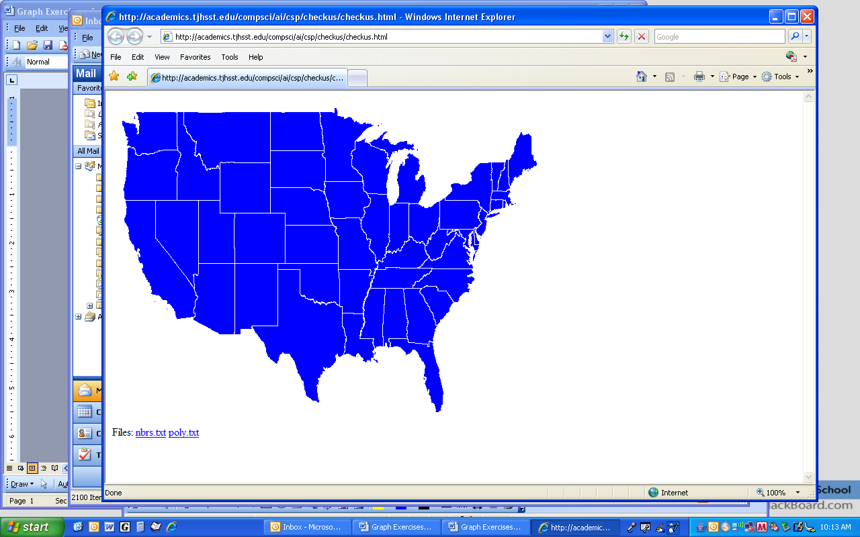

2a. Draw a graph that shows the neighbors of each state.

2b. Write an adjacency list for the neighbors of each state.

2c. (Optional) Choose an appropriate graph data structure. Create the input file. Create the driver class. Run the program and answer these questions:

Is ME reachable from VT? ________

Is VT reachable from RI? ________

Is CT reachable from ME? ________

Is this graph connected? ________

3. Consider the following directed graph. Assume that all lists of adjacent vertices are in alphabetical order.

3a. Write the breadth-first search order with S as the source.

3b. Write the DFS order for all vertices with S as the source.

3c. Suppose S, A, B, C, D, and E represent tasks that must be completed as part of a process and that an edge from X to Y means that X must be completed **before** Y. Name the algorithm you would use to find a valid order to complete the tasks.

3d. (Optional) Choose an appropriate graph data structure, write an input file, and check your answers above.

|  |  |
| --- | --- |
| ab | 5 |
| ac | 6 |
| ad | 5 |
| ag | 10 |
| be | 3 |
| bf | 6 |
| bc | 7 |
| ed | 12 |
| eg | 5 |
| ef | 2 |
| cf | 8 |
| cg | 6 |
| dc | 4 |
| df | 14 |
| fg | 3 |

4. Seven islands are to be connected by bridges. Each (two-lane) bridge costs several millions of dollars to connect two islands. You must decide which bridges to build so that traffic can drive between any two islands with the goal of minimizing the total cost of the bridges.

5

4a. State the name of the algorithm you will use to solve this problem.

4b. (Optional) Choose an appropriate graph data structure, write an input file, and check your answer above.